**Setting up Application Environment**

**Create Flask Project**

|  |  |
| --- | --- |
| Date | 07-11-2022 |
| Team ID | PNT2022TMID17200 |
| Project Name | CustomerCare Registry |

**Step 1.** Install Python latest version from python.org

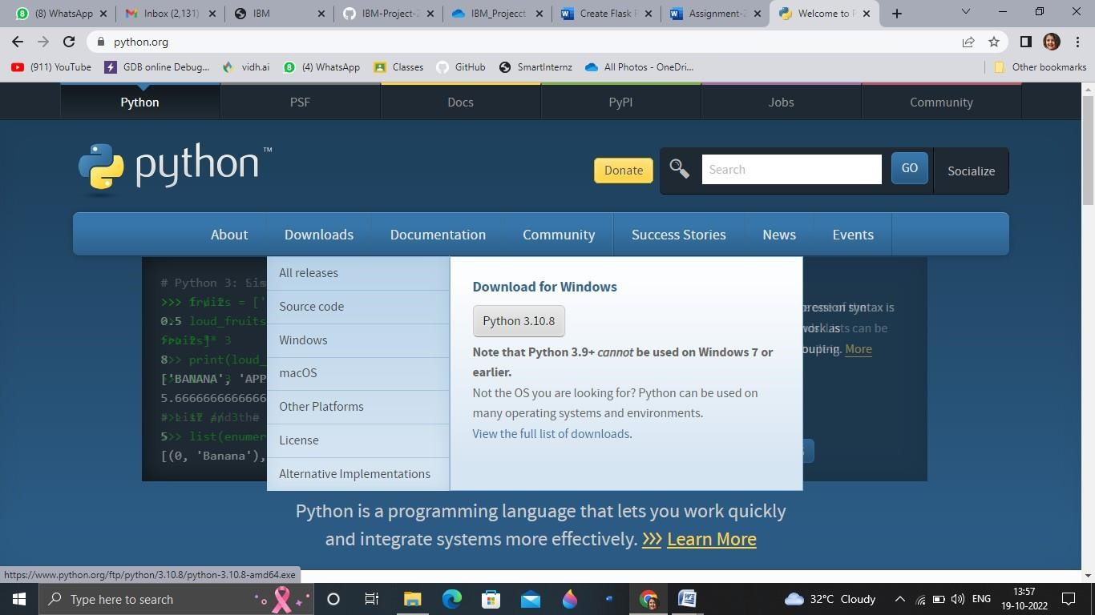

**Step 2**. Download Anaconda from [https://www.anaconda.com/a](https://www.anaconda.com/)nd install it by running the .exe file



**Step 3**.Install Flask using command pip install flask

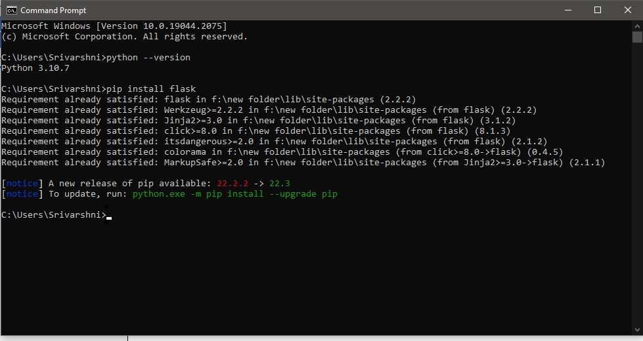

**Step 4**.Open a new Python file and start coding

from flask import Flask app = Flask(name)

@app.route('/') def hello():

return “Hello World”

ifname == ' main ': app.run(debug=True)

**Step 5**. Run the Python file using command python filename.py

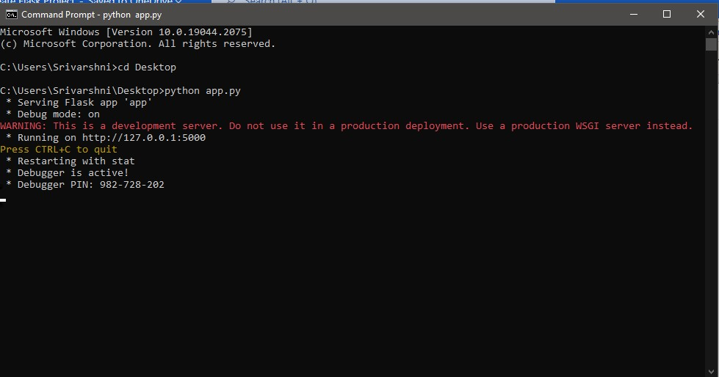

**Step 6**: Open the Ip in browser

